**Version 1.0: Authentication System**

Change Log (Version 1.0.0):

Successfully send data to MongoDB

Successfully send hard code data to MongoDB

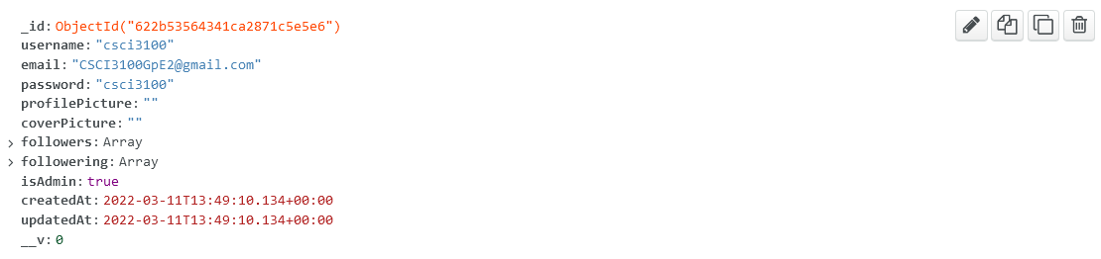

Change Log (Version 1.0.1)

* Successfully post data from POSTMAN to MongoDB. (Both login and register)
* Password is encrypted
* Designing a simple .ejs for login and register page with following URL

localhost:3000/login

localhost:3000/register

However, jQuery not yet implement. Will finish for next version.